|  |
| --- |
| **2025 12TH E-MOBILITY EXPO**  **NET-ZERO JEJU 2035** |
| **CONFERENCE OUTLINE** |

Overview

**ㆍ** **Period**

2025 4. 8(Thu) - 11(Fri) / 4Days

**ㆍ Place**

Jeju Shinhwa World Resort

**ㆍ** **Form of meeting**

Online & In person Concurrent

**ㆍProgram**

More than 130 sessions in 50 countries (scheduled))

**Main Conference (TBD)**

|  |  |
| --- | --- |
| ㆍThe 10th GEAN General Meeting & Forum | ㆍThe 4th World ESG Forum |
| ㆍThe Era of Grand Energy Transitions and  e-Mobility | ㆍInternational Autonomous Driving  & Microsatellite Business Forum |
| ㆍInternational Green Island Forum - Carbon Neutrality and Future Strategy Industry | ㆍRegional Leading Research Center(RLRC)  _Global Green Hydrogen Business Forum |
| ㆍESG Social Safety Net from EV Fire  & Sudden unintended acceleration | ㆍASEAN & Korea EV Business Forum  ㆍKorea & India e-Mobility Business Forum |
| ㆍGlobal Strategy Seminar for Implementing Public Transportation for Carbon Neutrality in the Asia-Pacific Region | ㆍKorea & China e-Mobility Business Forum  ㆍKorea & Africa e-Mobility Round Table  ㆍKorea & Arab e-Mobility Round Table |
| ㆍThe 3rd International Eco-Friendly  Vessels Expo | ㆍBusiness Networking Workshop for  Jeju, a Startup City |
| ㆍInternational EV Standards Forum | ㆍGlobal EV Battery Forum |
|  |  |
|  | ※The above program is subject to change |
|  |  |
|  |  |

|  |
| --- |
| **2025 12TH E-MOBILITY EXPO**  **NET-ZERO JEJU 2035** |
| **Conference Place Guide** |

**Conference Place Guide**

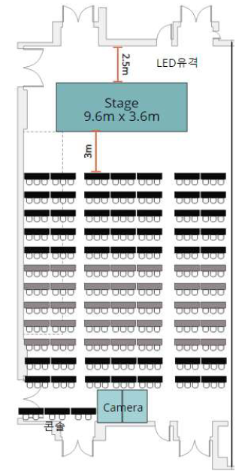**ㆍJeju Shinhwa World Resort Conference Room**

|  |  |  |
| --- | --- | --- |
| **SETUP**  **VENUE** | **SIZE (W x L x H)** | **Classroom Auditorium**  **(Table + Chair)** |
| Grand BallRoom | 16m x 29m x 7m | 250 seats |

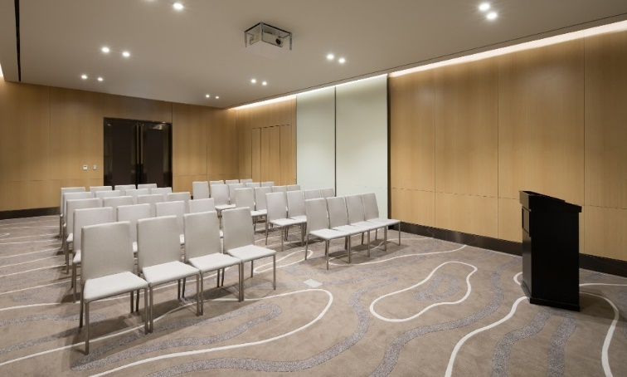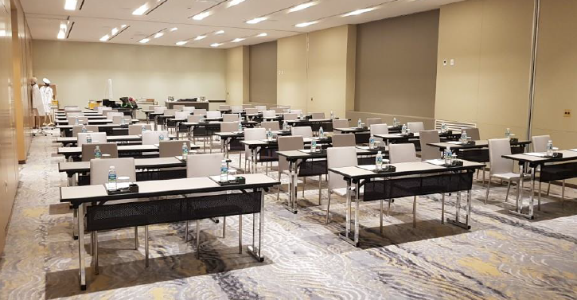

|  |  |  |
| --- | --- | --- |
| **SETUP**  **VENUE** | **SIZE (W x L x H)** | **Classroom Auditorium**  **(Table + Chair)** |
| Halla Hall | 24m x 8m x 3.3m | 150seats |
| Small conference room 1 | 6.3m x 10.9m x 3.5m | 50seats |
| Small conference room 2 | 6.3m x 10.9m x 3.5m | 50seats |
| Small conference room 3 | 6.3m x 10.9m x 3.5m | 50seats |
| Small conference room 4 | 6.3m x 10.9m x 3.5m | 50seats |
| ㆍCapacity: 80% of 1/2 capacity in case the stage/interpretation booth/system enters.  ㆍThe meeting place will be randomly assigned by the International Electric Vehicle Expo-  Organizing Committee according to the size. | | |

|  |
| --- |
| **2025 12TH E-MOBILITY EXPO**  **NET-ZERO JEJU 2035** |
| **Participation Fee** |

**Renting a Session Conference Room Fee**

**ㆍDefault Participation Fee**

|  |  |  |  |
| --- | --- | --- | --- |
| **SETUP**  **VENUE** | **SIZE (W x L x H)** | **Classroom Auditorium**  **(Table + Chair)** | **Default participation fee (3 hours)** |
| Grand BallRoom | 16m x 29m x 7m | 250seats | 5,000,000 |
| Halla Hall | 24m x 8m x 3.3m | 150seats | 3,000,000 |
| Small conference room 1 | 6.3m x 10.9m x 3.5m | 50seats | 2,000,000 |
| Small conference room 2 | 6.3m x 10.9m x 3.5m | 50seats | 2,000,000 |
| Small conference room 3 | 6.3m x 10.9m x 3.5m | 50seats | 2,000,000 |
| Small conference room 4 | 6.3m x 10.9m x 3.5m | 50seats | 2,000,000 |

※Vat excluded

**ㆍAdditional Services(Paid) (Landing Ball Room & Halla Hall Only)**

|  |  |  |  |
| --- | --- | --- | --- |
| **Sortation** | **Content** | **Unit price** | **Remarks** |
| Interpretation System | Interpreter booth | 1,000,000won | 1 booth per language |
| Interpretation (available for  language selection) | 2,400,000won | per language |
| Receiver | 200,000won | Based on 50 people |
| Video  conferencing system | Video conference system | 2,500,000won | Announcement of overseas victims, etc |
| Broadcast System | Broadcast System | 4,000,000won | External transmission system,  homepage, SNS, etc |
| ETC | ★Separate consultation with the organizing committee if additional matters are required | | |

※Vat excluded

**ㆍ** **Basic Service (Free)**

|  |  |
| --- | --- |
| **Sortation** | **Basic participation expenses (Organization Committee)** |
| Conference hall | Conference room (classroom auditorium setting provided) |
| AV equipment | Podium, Screen, Beam projector, Laptop 1ea, Microphone 2ea, Pointer 1ea |
| Prints | Basic production of the conference hall  (1ea each for title banners, guide banners, and podium boards) |
| Participant name tag |
| Event management | On-site field staff |
| ETC | ★Official Hotel Room Discount Offer (Reservation and Payment Separately)) |

**★Support for speaker invitations, accommodation, aviation..etc will be provided separately by institutions**

|  |  |  |
| --- | --- | --- |
| **Classification** | | **Details (Provided Benefits)** |
| **Entrance Fee** | **1day** | 1,000,000 won  (1 time of business networking dinners and lunches, Carbon Neutral Business Networking Jeju Tour Program: Choose one from A, B and C courses ) |
| **2days 1night** | 1,500,000 won  (Jeju Shinhwa World Hotel 1 nights, 1 breakfast, 2 time of business networking dinners and lunches, Carbon Neutral Business Networking Jeju Tour Program: Choose Two from A, B and C courses ) |
| **3days 2nights** | 2,000,000 won  ( Jeju Shinhwa World Hotel 2 nights, 2 breakfast, 3 times of business networking dinners and lunches, Carbon Neutral Business Networking Jeju Tour Program: Choose Three from A, B and C courses ) |
| **Validity** | | Only from the date of ticket issuance to the relevant period for  ( Need contact for participation in the pre-conference event ) |
| **Available Participation contents (common)** | | Conference site viewing, conference online viewing, exhibition/test driving |

**Conference Registration Fee**

|  |
| --- |
| **2025 12TH E-MOBILITY EXPO**  **NET-ZERO JEJU 2035** |
| [**www.ievexpo.org**](http://www.ievexpo.org)  **Contact Secretariat: TEL：064-702-1580 E-mail：**[**conference@ievexpo.org**](mailto:conference@ievexpo.org)  **Conference Responsibility : Kim Min A 010-5421-7123** |